1. Before updating

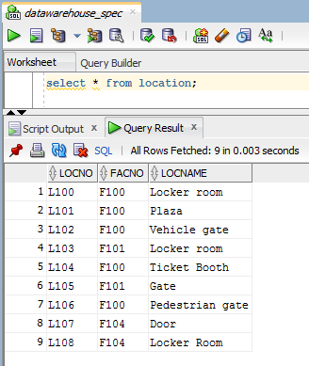

2. Updating

UPDATE Location

SET LocName = 'Gate'

WHERE LocName = 'Door';

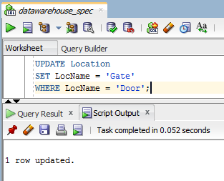

3. After Updating

